Logbook 2 Template (for offline log preparation)
Name: | Kaung Linn Aung
Week Date: | Part A -Meeting 2 of 8
(The above information is for you to keep track of which week this log is applicable for. This information is not required in the online logbook as the system will find your name, your supervisor’s name, and take the submission date, automatically. You must submit the online log in the relevant week. Logs cannot be backdated to missed weeks.)

Meeting date:  (please note if no meeting is planned this week) | Date and day  09-June-2026
Work Undertaken this week:  Not more than 500 words | From the first meeting until now, what have you done based on the task you have listed in the last logbook?  - Comprehensive Itemized Procurement List: A list of all the components was prepared and cross checked with the inventory of Electronics and Mechanical Lab in the University. The estimated total cost of the out-of-pocket expenses was minimized by using lab allocated assets (baseline Raspberry Pi 4, Bambu 3D printing infrastructure).  - Conceptual 2D Hull Layout & Sizing: Flat orthographic cross-sections of the main pressure vessel were drawn, as were structural dimensions. The internal volume of the equipment sled was determined by choosing a 200mm diameter thick-walled PVC plumbing cylinder as the baseline volume.  - The concept of Hardware-Software Communication Architecture between the master processing unit and slave microcontroller was developed for the serial data packet structure. Data fields were created to send over the filtered telemetry arrays and navigational vectors with minimal propagation delay.  - Safety & Regulatory Literature Review: Standard operating procedures for Lithium-Polymer (Li-Po) battery containment in unvented, sealed marine hulls were reviewed to create thermal safety baselines.
Problems encountered:  (Not more than 500 words | What are the tasks that are still understanding  Two critical structural and processing limitations were identified during the supervisor review session, leaving several tasks outstanding:  - Raspberry Pi 4 CPU Processing Constraints: Modelling showed that doing this with just the Raspberry Pi 4 CPU would cause significant lag in processing when trying to log video at high resolution and analysing the frames in real-time with a Convolutional Neural Network (CNN). It's a great need to evaluate the other single-board computers (SBCs).  - Inadequate 2D Layout Sketching: The 2D geometric sketches were found to be inadequate by the supervisor for checking physical spatial tolerances, packing density of components and O-ring face-seal compression points. Making the transition from a flat 2D workspace to a high fidelity 3D modeling space is a key outstanding design challenge that must be addressed for the final Project Outline.
Tasks agreed for upcoming week before the next meeting | What are your plan actions/task until the next progress meeting that are agreed with your supervisor  Task 1: Migration to 3D Conceptual CAD Modeling  Using modeling software (SolidWorks, CATIA etc.), a 3D isometric conceptual CAD model or assembly drawing will be created. This model will be used to visually describe the external hull, placement of 3-axis thrusters and the internal component layout of the equipment sled that will slide within the hull to ensure spatial clearance.  Task 2: Nvidia Jetson Nano & LattePanda Feasibility Study  Technical investigations will be carried out on the 128-core Maxwell GPU architecture of the Jetson Nano and the x86 framework of the LattePanda to assess their ability to execute computer vision hardware acceleration models for their respective thermal footprints.  Task 3: Sourcing Strategy Optimization  A technical trade-off matrix will be created to score the computing cores, and the university Robotics & AI Lab inventory will be cross-referenced to determine if any free-use developer kits are available.
Figures:  (Upload image files in the online Log Form, but feel free to keep notes here about which images you intend to upload. Use “Figure Caption” information as the filenames, e.g., “Figure 1 – A screenshot of the initial constrained Sketch in CATIA.jpg”) | - Update Hardware Block diagram of your system  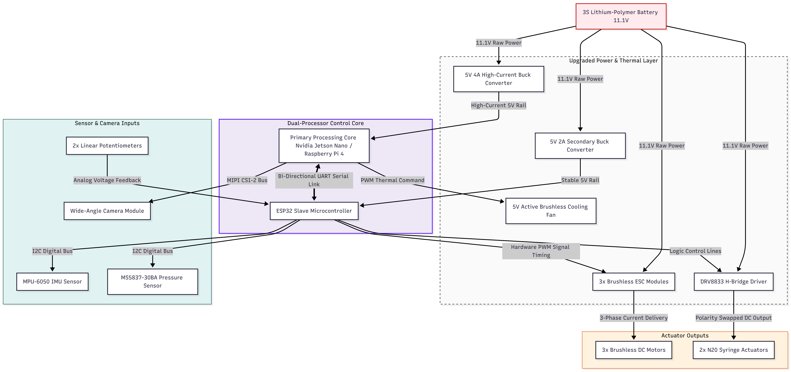Figure 1: Dual-Tier Hardware Architecture and Component Block Diagram for the AUV Scout.  Justifications for technical additions.  The diagram includes three specific changes beyond the baseline components list:  Nvidia Jetson Nano Option: Added to the primary processing block to test an alternative to using a GPU for computing for AI frame analysis.  5V Active Brushless Cooling Fan: New addition to help keep the other Jetson Nano board from over heating inside the un-vented PVC pressure hull.  5V 4A High-Current Buck Converter: Added to ensure stability of the power rail when the Jetson Nano is under heavy AI workloads, when standard low amperage hobbyist regulators are not capable of providing the necessary current.  - Key software codes/modules that need to be developed  Module 1: UART Serial Packet Parser & Handshake Link  Focus: Manages the low latency serial communication protocol between the master single board computer and slave microcontroller. This module specifies the structures of data packets for exchange of telemetry vectors and navigational commands.  Module 2: I2C Digital Sensor Fusion & Data Filtering  Focus: Controls the high-frequency digital polling functions to the MPU-6050 IMU and MS5837-30BA hydrostatic pressure breakout sensors. Incorporated here is the low pass filtering logic to remove signal noise that results from motor transients.  - Any Quality and Regulatory issues addressed?  Thermal Mitigation for Upgraded SBCs: Higher power processing options (Nvidia Jetson Nano or LattePanda) inside an unvented PVC hull not only adds to the risk of heat buildup, but also increases the likelihood of equipment failure. An active, hardware-controlled 5V cooling fan loop was added to the system architecture, to ensure that there is no computational thermal throttling.  Mechanical sealing tolerances were calculated in an isometric 3D CAD environment, instead of using flat drawings, with 3D Tolerance Modeling. Low cost structural components such as nitrile O-ring grooves were optimized on the 3D-printed PETG end-caps to ensure the hydrostatic pressure causes the same 25% deformation across the entire seal, thus making it suitable for use.  UART Communication Heartbeat Failsafe: Software layer handshake check added to serial communication firmware to provide continuous handshake checking. When the data transmission between master edge processor and slave microcontroller is lost for more than 3.0 seconds, the ESP32 automatically initiates an override routine, operating the N20 motors to completely discharge the syringe ballast, thereby safely surfacing the AUV.  - A updated/improved version of your system sketch  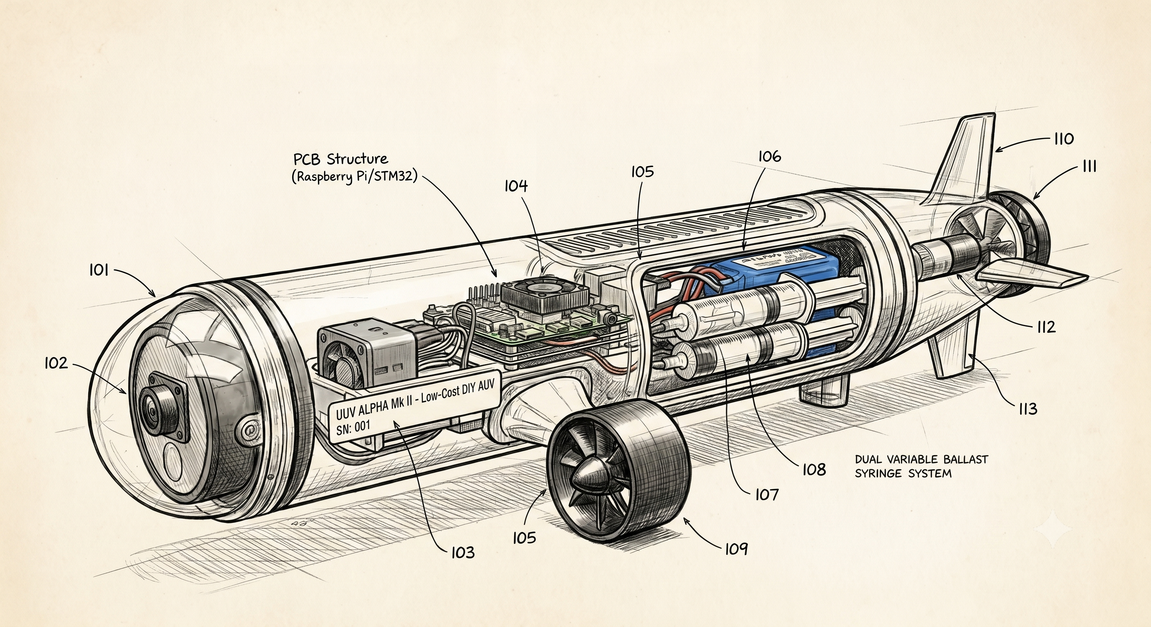Figure 2: Technical Schematic of the Autonomous Underwater Vehicle (AUV) 'Scout' Prototype

